CS-010 CF Grounding & Electrical Bonding
Doc ID | CS-010
Title | Carbon Fiber Grounding & Electrical Bonding
Revision | C
Status | Draft, pending Lead signature
Effective date | 2026-08-28
Supersedes | Tribal grounding knowledge from SN5 trials

Approvals
Role | Name | Date
Author | Simon Starbuck (drafted with Claude, SN6 Resources) | 2026-07-12
Reviewer | simon (reviewer agent)
Approver (Composites Lead)

Revision history
Rev | Date | Author | Description of change
A | 2026-07-12 | Claude | Initial issue, encodes the diffuser-validated method + the catch-can decision lesson
B | 2026-07-28 | Claude | Language pass: fewer em dashes for rhythm variety, no content change.
C | 2026-08-28 | Claude | Engineering pass (CS-000 Rev C conventions). Figure 1 draws the diffuser recipe in plan: mesh sheets, the 25 mm overlap, the terminable tail, and the probe pattern that proves the part. One intensifier cut from §1. No rule changed.

1. Purpose
EV rules want conductive parts near HV/chassis grounded (our SN5 working criterion: <5 Ω to the grounding point). SN5 gave us both the success story and the cautionary tale. The diffuser (target and method written down up front, copper mesh in the stack) validated at <1 Ω continuous everywhere (2026-06-21) and drew praise from the design judges at comp. The catch can had no written criterion; its method was improvised for six months (Nov→May) and never hit target with CF wrapping, so we finally solved it by giving up on CF for that geometry and going to epoxy + copper paths (PP-05). This doc exists so we repeat the first one.

2. Scope
Any CF part with a grounding/bonding requirement, and any conductive-path retrofit on existing parts. The Ω target and rule interpretation come from the EV rules owner (powertrain/rules lead); this standard covers how composites achieves and proves the target, not what the target legally is.

3. References
Ref | Document | Where
R1 | PP-05 RCA (catch-can saga) | FEB-COMP-PP-001
R2 | CS-002 (mesh in the ply table) | CS-002 §7.1
R3 | SN5 grounding trials: graphite powder judged insufficient vs copper mesh (Nico, #composites, Nov 2025) | Slack record
R4 | Diffuser validation <1 Ω (post-comp recap) | #composites, 2026-06-21

4. Definitions
- Grounding point: the fastener/tab where the part's conductive path meets chassis ground.
- Probe pattern: the defined set of surface points measured against the grounding point.
- CF as conductor: carbon laminate conducts, but through-thickness resistance through resin-rich layers is high and unpredictable; bare CF also can't be reliably terminated. Hence copper mesh.

5. Equipment & Materials
Item | Spec / product | Source | Notes
Copper mesh | Fine woven mesh (repeat team buy) | Amazon | The validated conductor (R3, R4)
Multimeter | 2-wire, known-good leads | Electrical | Zero the leads first (touch together, note offset)
Ring terminals / grounding hardware | Per part design | McMaster
Graphite powder | 1–5 wt% in resin | Sigma-Aldrich | Secondary/supplement only; insufficient alone (R3)

6. Safety
Grounding verification happens on or near the car: follow EV safety rules. No probing near energized HV; HV isolation confirmed by the ESO before resistance measurements on installed parts. Bench measurements on loose parts: no special hazards beyond CS-009 dust rules if sanding contact points.

7. Procedure

7.1 Decision point first (the catch-can lesson)
- Before any layup work, answer on the WO: is CF-with-copper-mesh the right conductive path for this geometry?
- Good fit: large open laminates (diffuser, panels) where mesh lays flat in the stack and terminates at accessible flange points.
- Bad fit: thin-walled, tapered, or wrapped metal substrates (the catch can: sanding punctured the can wall at the taper; through-thickness contact never stabilized). For these, use epoxy + copper strip/braid paths bonded to the surface, or reconsider whether the part needs CF at all.
- Write the acceptance criterion on the WO before work starts: Ω target, probe pattern (grid spacing or named points), and measurement method (7.3). Six months of drift happened because none of this was written (R1).

7.2 Build the path (mesh-in-stack method: the diffuser recipe)
- Put copper mesh in the ply table per CS-002: mesh layer(s) positioned to be continuous from part surface zones to the grounding point(s), 25 mm minimum overlap where mesh sheets meet.
- Mesh must reach the grounding point as bare, terminable material: leave a mesh tail at the flange/fastener location, protected during infusion (peel-ply window or masked zone).
- For surfaces needing exposed conductivity, an 88-gsm outer ply over mesh keeps finish while staying thin; validate on the first article that surface-to-ground still passes.
- Graphite powder (1–5 wt% in the resin) may be added as a supplement in zones where mesh coverage is marginal, never as the primary path (SN5 trials judged it insufficient alone, R3). If used, record wt% on the WO.
- Infuse/laminate per CS-006/CS-007. Note on the WO where mesh actually ended up (as-built).
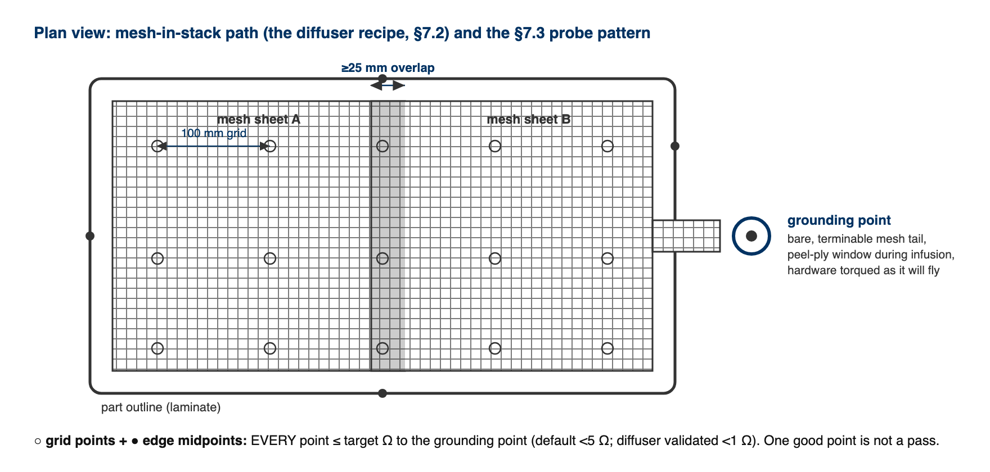
Figure 1. The mesh-in-stack path in plan: sheets overlapping ≥25 mm, a bare terminable tail at the grounding point, and the default probe pattern (100 mm grid plus edge midpoints). Every point measures to the grounding point; every point passes or the part does not.

[ PHOTO: copper mesh tail at grounding point before bagging ]

7.3 Measure: one method, every time
- Zero the multimeter leads; record lead resistance.
- Fasten the grounding hardware as it will fly (torqued, washers as designed); hand-held contact readings are noise.
- Probe every point in the WO's probe pattern (default: 100 mm grid over conductive zones + every edge midpoint) to the grounding point. Record each value minus lead offset.
- Pass = every point ≤ target (default <5 Ω, or the rules value on the WO). Not "one good point": that ambiguity burned a month in May 2026 (R1).

7.4 If it fails
- Map the failing zone; usually a mesh discontinuity or resin-isolated overlap.
- Fixes in order of preference: expose + bond a copper strip bridge (epoxy + copper path), add an external ground tab at the failing zone, or lightly abrade to mesh at a termination point and re-terminate. Do not sand thin laminates chasing contact. That is how the catch cans died (R1).
- Re-measure the full pattern after any fix, not just the failed point.

8. Quality checks / acceptance criteria
Check | Target | Method | Record where
Criterion written before work | Ω + probe pattern + method on WO | WO blocker step | WO
Decision point answered | CF-mesh vs alternative path, with one-line why | WO field | WO
Resistance | Every probe point ≤ target | §7.3 method | WO qualityChecks (full table of readings)
As-built mesh record | Matches or deviations noted | CS-002 §7.4 | WO

9. Records
The WO keeps: the decision-point answer, criterion, full probe-reading table (values, not "pass"), photos of mesh placement and termination, and any retrofit fixes. The diffuser's <1 Ω table is the reference example once WO-SN5 retro-records are loaded.

